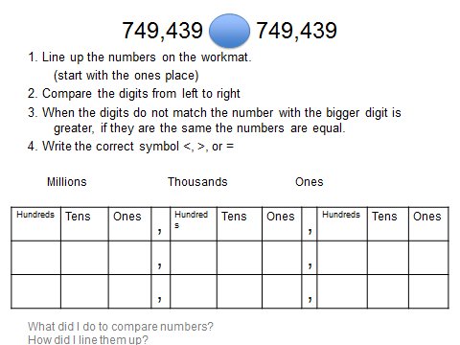

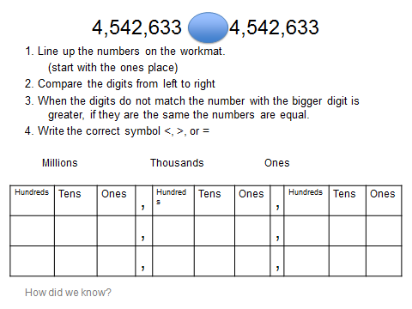

Directions: Order the numbers in each question from greatest to least.
1. 456, 789 455,789 455, 879 1, 456, 789

2. 567, 890 566, 890 Five Hundred sixty six thousand ninety

3. 1, 456, 780 455, 780 678, 090

